Circuit Analysis (Lab # 6)

Experiment 6: VERIFICATION OF KIRCHHOFFS LAWS

Name: Muhammad Abdullah Registration No: 2025-CE-54
Date: 29-April-2026 Grade and Signature: ………………………
CLO2  CLO3 | Use with identification the circuit components, breadboards,  multimeters, power supplies, signal generators, and oscilloscopes. Make measurements in their own constructed electric circuits.
Psychomotor/Affective | Level1 (1) | Level2 (2-3) | Level3 (4-5) | Level4 (6-7)
Report Marks (3) |  |  | Total marks (10)

Objective
To verify Kirchhoff’s current law and Kirchhoff’s voltage law for the given Circuit.

Apparatus Required
Sr. no | Apparatus | Range | Quantity
1 | Regulated Power Supply | Standard | 1
2 | Signal Generator | Standard | 1
3 | Oscilloscope | Standard | 1
4 | Digital Multimeter | Standard | 1
5 | Breadboard & Wires | Standard | As Required
6 | Resistors | 330ohm, 220ohm 1kohm | 3
Description
KCL: The algebraic sum of the currents meeting at a node is equal to zero.
KVL: In any closed path / mesh, the algebraic sum of all the voltages is zero.
Precautions:
- Voltage control knob should be kept at minimum position.
- Current control knob of RPS should be kept at maximum position.

Procedure for KCL:
- Give the connections as per the circuit diagram.

- Set a value in RPS.

- Note down the corresponding readings using multimeter

- Repeat the same for different voltages

Circuit - KCL
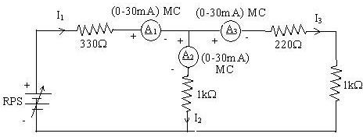
KCL - Practical Values:

Sl. No. | Voltage E | Current |  |  | I1 = I2 + I3
 |  | I1 | I2 | I3
 | Volts | mA | mA | mA | mA
1 | 5 | 5.68 | 3.12 | 2.56 | 5.68
2 | 15 | 17.1 | 9.37 | 7.68 | 17.05 (or 17.1)
3 | 25 | 28.4 | 15.6 | 12.8 | 28.4

Procedure for KVL:

- Give the connections as per the circuit diagram.

- Set a value in RPS.

- Note all the voltage reading

- Repeat the same for different voltages

Circuit - KVL
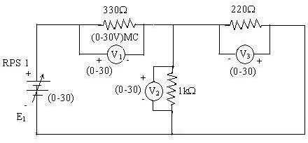

KVL - Practical Values

Sl. No. | RPS | Voltage |  |  | E1 = V1 + V2
 | E1 | V1 | V2 | V3
 | V | V | V | V | V
1 | 5 | 3.23 | 1.77 | 1.77 | 5.00
2 | 10 | 6.47 | 3.53 | 3.53 | 10.00
3 | 15 | 9.70 | 5.30 | 5.30 | 15.00

Result:
Thus, Kirchhoff’s voltage law and Kirchhoff’s current law are verified practically by performing this experiment.

Post Lab Questions

1. Define Kirchhoff’s current law.
Kirchhoff’s Current Law (KCL) states that the total current entering a junction, or node, in an electrical circuit is exactly equal to the total current leaving that same junction. In other words, the algebraic sum of all currents meeting at a single node is zero. It is essentially the principle of conservation of electric charge applied to circuits—charge does not just magically disappear or build up at a wire connection; whatever flows in must flow out.
2. Define Kirchhoff’s voltage law.
Kirchhoff’s Voltage Law (KVL) states that in any closed loop of a circuit, the total voltage supplied is exactly equal to the sum of all the voltage drops across the components in that same loop. Stated differently, the algebraic sum of all voltages around any closed path is zero. This relies on the conservation of energy, meaning whatever electrical energy the power source (like a battery) puts into the loop, the resistors and other components will use up exactly that same amount.
3. What are the applications of regulated power supply?
A regulated power supply (RPS) is designed to ensure that the output voltage remains constant and stable, regardless of changes in the input voltage from the wall or fluctuations in the load current. Some common applications include:
- Laboratory Testing: They are heavily used in engineering labs to safely test electronic components and circuits with a precise, steady voltage.
- Computers and Electronics: The power supplies inside our PCs and laptop chargers use regulation to keep sensitive microprocessors running without crashing.
- Medical Equipment: Devices like heart monitors rely on regulated power to ensure accurate readings without electrical interference.
- Telecommunications: Used in radio and broadcast equipment to provide clean power and prevent static or signal noise.
4. What are the limitations of KCL?
While KCL is a fundamental rule for basic circuit analysis, it does have a couple of limitations. First, it is based on the "lumped parameter" model, which means it works perfectly for standard DC and low-frequency AC circuits. However, it fails in very high-frequency AC circuits (like microwave engineering) where the physical length of the wires is comparable to the wavelength of the signal. Second, it assumes that there is absolutely no accumulation of charge at the junction itself. If a circuit has rapidly changing electric fields that cause charge to momentarily build up at a node (due to parasitic capacitance), the simple "current in equals current out" equation becomes inaccurate.

